Azamat Salamatov

Doctor Tai Cleveland

COMP-3324 – Computer Networks

Week 4 - Lab 4 - SNMP

3/12/2023

SNMP

Contents

Image: 1

What I learned: 1

# Image:

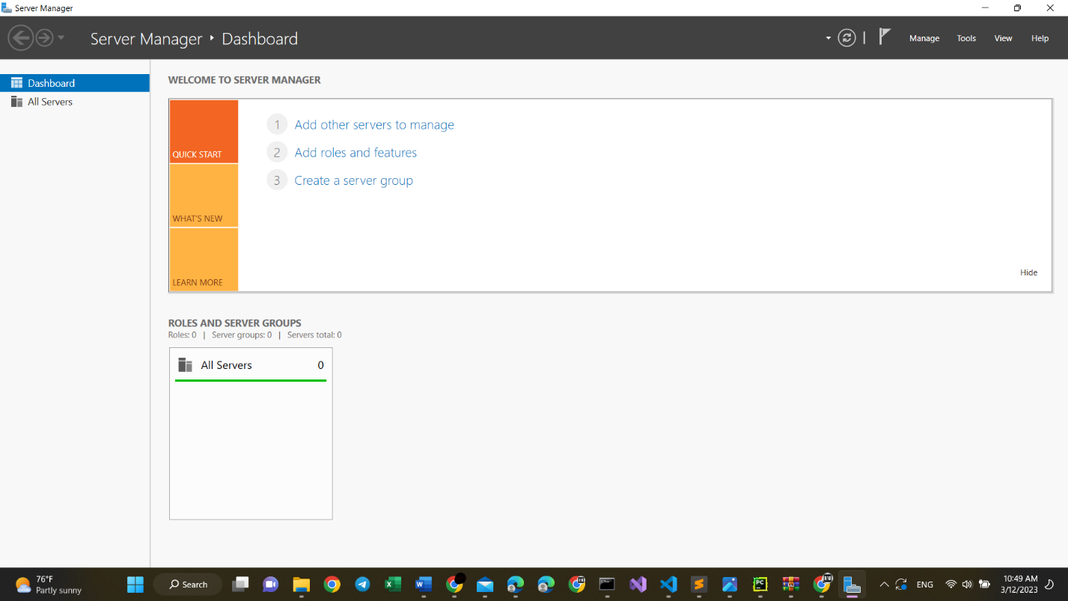

# What I learned:

* While following the Tutorial Documentation Provided on the portal:
  + I could do nothing;
* So, I did almost everything myself:
  + I had to download Server manager, because it is not provided in windows 11 automatically;
  + I had to configure all the setting to be able to add a new server
  + And finally, adding a new role to a server is not possible, here is the photo:

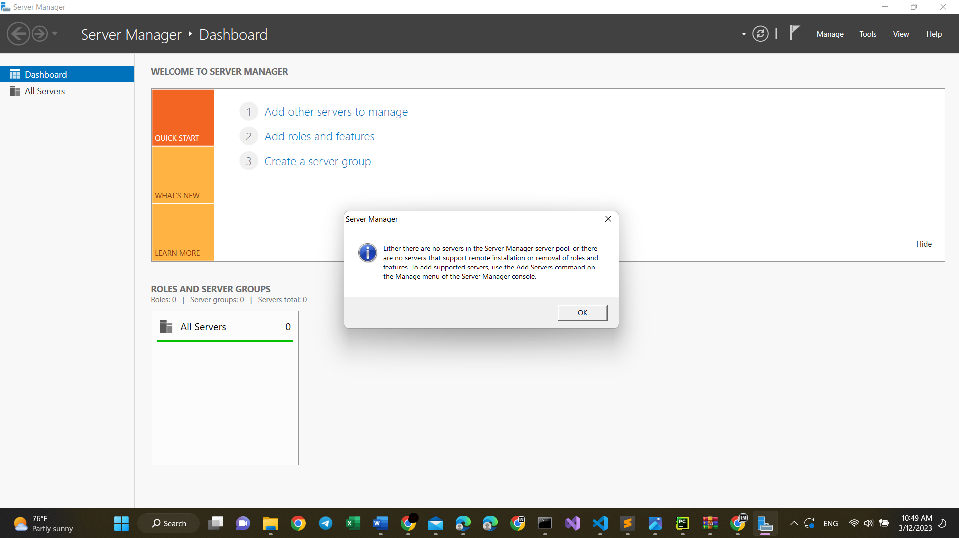

* It is because I am already connected to the University’s server
* And adding a new server is not available
* However, If I have a possibility to add a new role to the server I can do it.
* Maybe, I need another laptop with its own server.